CISpaces Web Services Development Guide
J.S.Robinson@soton.ac.uk

A short introduction to developing and debugging the CISpaces Web Services component This guide assumes the reader has some programming experience, is familiar with the Linux command line, and has a GitHub account.

Architecture
The CISpaces user interface is browser based, employing the D3 Javascript library for visualization and Backbone.js for communication with the backend via HTTP / AJAX / JSON.
The back end web services run on Apache Tomcat, a Java based web application server.
Data storage is managed by an Apache Derby instance, running in standalone mode.

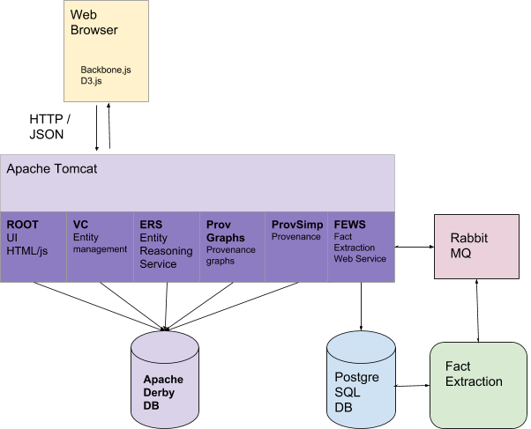
The Fact Extraction service parses social media streams to identify supplied topics and provide evidence to support or reject them. Communication with the fact extraction service is via the Rabbit MQ message bus. Fact extraction data is stored in a PostgreSQL database.

Forking the CISpaces Web Services Git Repository
- Visit https://github.com/CISpaces/webservices
- Sign in to GitHub
- Click the Fork button in the top right
- Note the URL of your forked repository

Environment
For clarity, here we will set up a virtualized development environment running Ubuntu, independant of the host operating system.

- Download and install Oracle VirtualBox and create a new virtual machine with at least 20GB storage and 2GB RAM
- Download the Ubuntu 16.04.x 64-bit Desktop ISO and install into the VM
- In a terminal inside the VM run:
$ sudo apt-get install virtualbox-guest-dkms
- Enable VirtualBox shared clipboard: Devices->Shared Clipboard->Bidrectional

Install the prerequisites and build CISpaces
Inside the VM:
- Install git:
$ sudo apt-get install git
- Clone your fork of the CISpaces repository:
$ git clone https://github.com/YOUR_GITHUB_USER_ID/webservices.git
- Run the pre-requisites installation script from the webservices directory:
$ cd webservices
$ ./install-prereqs.sh
- Install the Fact-Extraction service (can take up to 15 minutes)
$ FEWS/extra/install-fact-extraction.sh
- Update the environment
$ source ~/.profile
- Add local dependencies to Maven:
$ mvn initialize
- Build and deploy the CISpaces Web Services using Maven:
$ mvn install

Running CISpaces
- To start:
$ ./start-cispaces.sh
- Start the fact-extraction engine running in a Screen session
$ screen
$ cd ${CISPACES}/tools/fact-extraction
$ source env/bin/activate
$ ant run.fact-extraction-app
$ <CTRL+A>,<D>

- Install Chromium browser
$ sudo apt-get install chromium-browser
- Navigate to http://localhost:8080
- Log in with Ella / password
- Import a CIS file from webservices/example_cis_files

Developing CISpaces

Installing Netbeans
- Install the full version of the Java Development kit:
$ sudo apt-get install openjdk-8-jdk
- Download the Netbeans IDE. Select the full (‘All’) version.
- To install, from the terminal run:
$ bash ~/Downloads/netbeans-8.2-linux.sh
- Don’t install JavaME, PHP, C/C++, Groovy, GlassFish or Tomcat.
- When prompted, select the JDK at /usr/lib/jvm/default-java

Building the Project
- File -> Open project -> webservices (Select) Open required projects
(This may take a while)
- Open a terminal or in Netbeans, Window->IDE Tools ->Terminal
- $ cd ~/webservices
- $ mvn install
- This will compile and package all the Java Web Services and deploy them to the tomcat instance located in:
~/webservices/cispaces/tools/tomcat
- You can examine the application logs in:
~/webservices/cispaces/tools/tomcat/logs/catalina.out

- Open the Services Tab -> Servers -> (right click) Add Server.
Select ‘Apache Tomcat or TomEE’
Server location ~/webservices/cispaces/tools/tomcat
Add manager credentials - manager / manager
Right click the new entry and choose Start in Debug Mode
- The application is now availabe at http://localhost:8080

Debugging Java Web Services
- Double click a module in the Projects Pane, e.g. VC. (It opens underneath).
- Expand: Source Packages, vcservlet
- Open File VCServlet.java
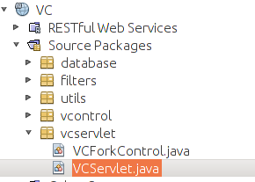

- Place a breakpoint on line 260 by clicking on the line number
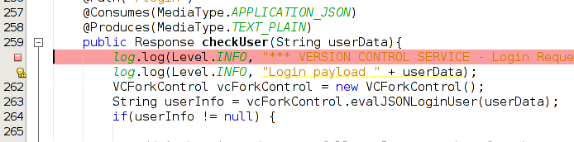

- Click the dropdown menu on the Debug Project Button in the Toolbar
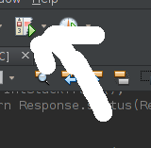

- Choose Attach debugger
  - Java Debugger (JPDA)
  - Socket Attach
  - Dt_socket
  - Host: <your host name>
  - Port: 11550

- Navigate to http://localhost:8080 and try to log in. Execution will stop at your breakpoint and you can examine variables / evaluate expressions. Click the green arrow in the toolbar to continue execution.

https://cispaces.org/
https://github.com
https://www.virtualbox.org/wiki/Downloads
http://releases.ubuntu.com/16.04/ubuntu-16.04.4-desktop-amd64.iso
https://netbeans.org/downloads/

